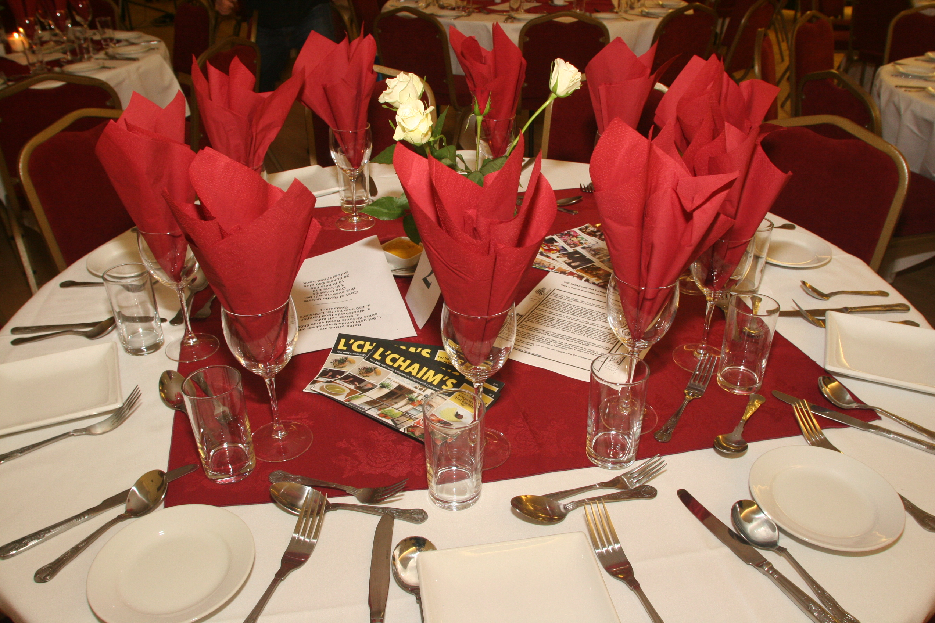
THESE PRICES ARE PRE-COVID.
MENUS & PRICES HAVE CHANGED
PLEASE CONTACT US FOR CURRENT
MENUS & PRICES

L’Chaim’s Kosher Catering
Scotland’s Only Glatt Shomer Shabbos
Kosher Restaurant & Food Supplier
Dining & Bespoke Meals at it’s Best
We Deliver Throughout Scotland
'Delivery Charges Apply'
Tel: 0141 638 6116
Email: lchaimsglasgow@aol.com
When ordering your Meals Please
Highlight in Yellow items you require
Save the document and email it back to us.
Please only email the sections you require not the entire document.
You can also call to give your order
Payment for meals should be made
when ordering your food.
Paying by UK Credit Card? Add 5% on orders under £100.
Paying by overseas Credit Card? Add 5% charge to cover currency exchange charges on all payments
Paying by bank transfer all bank charges must be
paid by the client
Larger & Bulk Orders carry a 5% Food Handling Charge
To avoid disappointment all food/meal orders should be given at least 48 hours in advance.
In an emergency always contact us and we will do our utmost to meet your requirements.
We use Shefa Meats under Hashgocha of
Rav Zimmerman of Federation (Former Gateshead rov)
Rav Eckstein of Belzer & Rav Eliezer Schnebalg of Edgware

Milk & Cheese supplied is always Cholov Yisroel
All Main Courses to be heated are double wrapped
and are to be heated in a microwave unless otherwise requested.
Currently there is a charge for all plastic and porcelain plates, plastic and stainless steel cutlery. Rolls and bread supplied extra on request. Contents of meals may change without notice.
Bespoke Meals
Our chefs can create matching menus for corporate or private functions taking place in any hotel, restaurant or banqueting room.
Delivery Options
We deliver throughout Scotland and the north of England. Please ask for delivery quote.
Staying at a Hotel
We find most hotels in Scotland will store and heat our food because we have full HACCP traceability and are regularly inspected by the local authority and can sign a disclaimer.
However, it is the clients duty to contact their hotel and confirm in writing that they are willing to store and heat their kosher food.
Our restaurant and plant is inspected annually by the
Environment Department of East Renfrewshire Council.
Under the Food Safety Act 1990 andThe Food Hygiene (Scotland) Regulations 2006. The Food Hygiene (Scotland) Regulations 2006
Our last inspection was carried out on 25/01/19
We PASSED The Food Hygiene Inspection on 25/01/19
We Passed An External Food Safety Audit
Carried Out By GWB Safety Solutions Ltd
Company Reg No: 06028847 Tel: 07736 089 539
On 12/10/15
Starters  Fan of Melon and Seasonal Berries  Starter Salad  Scottish Smoked Salmon  Scottish Smoked Salmon and Melon  Egg & Onion with Matza Crackers  Chopped Liver with Matza Crackers  Egg & Onion & Chopped Liver with Matza Crackers  L’Chaim’s Home Made Butter Nut Squash Soup  L’Chaim’s Home Made Lentil Soup  L’Chaim’s Home Made Chicken Soup and Knaydlech | £4.50  £5.00  £7.00  £5.50  £4.00  £6.50  £5.50  £4.50  £4.50  £5.50
Main Courses Come Frozen Unless stated. Salads are not Frozen. All Meals served with a roll.  Rib Beef with Red Wine Sauce, Garlic Mashed Potatoes, Roast Carrot & Turnip.  Roast Shoulder of Lamb in red wine and red currant jus. Boulongaire Potatoes and Ratatouille  Chicken BBQ, with Rice & Ratatouille  Chicken Roast in wine gravy, with Rice & Ratatouille  Meatballs in Red Onion Gravy, with Mashed Potatoes and Garden Peas.  Cold Meat Selection of Home Made cuts to include EITHER Turkey, Roast Beef or Salt Beef served with Three Salads.  Haddock Provencale, Mashed Potatoes served with Petit Pois.  Scottish Smoked Salmon Salad served with Three Fresh Salads.  Scottish Poached Salmon Salad served with Three Fresh Salads.  Vegetarian Options  Avocado Salad.  Vegetable Lasagne, served with Fresh Salad and a French Baguette or roll.  Roast Pepper stuffed with Soya Mince, Rice, Pine Nuts, etc served with Fresh Salad and French Baguette or roll. | £16.50  £18.00  £16.00  £15.00  £11.50  £18.50  £12.50  £17.50  £18.00  £10.50  £14.50  £14.50
Desserts  L’Chaim’s Fresh Fruit Salad  L’Chaim’s Fresh Fruit Platter  Chocolate Tart  Chocolate Mousse  Chocolate Gateaux  Apple Pie  Lemon Tart  5 Assorted Pastries  Tea & Coffee with China Cup and mints  Tea & Coffee with Plastic Cup and mints | £6.00  £10.00  £5.00  £4.50  £5.50  £5.00  £6.00  £6.00  £5.00  £3.50
Shabbos Meals  All Shabbos Meals supplied with 2 Chala Rolls if you are one person, one chala roll per person per meal if it is more than one person ordering Shabbos food.  Wine and Grape Juice extra as below.  Main course can be heated before Shabbos begins.  Friday Night Meal  Starter: Choose from: Scottish Smoked Salmon, Chopped Liver served with Egg & Onion, a Fan of Melon with Seasonal Berries.  Main Course: Roast Chicken in a wine gravy, Sweet Carrots, Kugel and Rice.  Dessert: Choose from: – Gateaux, Apple Pie, Lemon Tart, Chocolate Tart, Chocolate Mousse, Fresh Fruit Salad,  Shabbos Chicken Soup and Knaydels (if you can keep it hot)  This Meal costs £27.00 per person. (Chicken Soup extra).  Buy two or more of same meal (all courses) £26.00 p/p. | £26.50  £5.50
Shabbos Lunch  Starter: Choose from: Egg & Onion & Liver, Scottish Smoked Salmon, a Fan of Melon with Seasonal Berries.  A Selection of Home Made Cold Meat cuts to include EITHER Turkey, Roast Beef or Salt Beef or Smoked Salmon with Three Salads.  Dessert: Choose from: – Gateaux, Apple Pie, Lemon Tart, Chocolate Tart, Chocolate Mousse, Fresh Fruit Salad  Buy two or more of same meal (all courses) £26.00 p/p.  Cholent in Slow Cooker and serving spoon for up to six people.  Cholent ONLY for up to six people  Larger Cholent and Slow Cookers available please ask.  Shalosh Seudos Two Course Meal:  Shalosh Seudos Three Course Meal:  Starter: a Fan of Melon with Seasonal Berries.  Main Course: Choose Either: Scottish Smoked Salmon, or Fried Fish, or Scottish Poached Salmon served with two Salads.  Desserts choose from list in other Shabbos Meals.  Buy two or more of same 2 course meal (all courses) £18.00 p/p.  Buy two or more of same 3 course meal (all courses) £21.00 p/p.  Vegetarian Salad option available | £27.00  £35.00  £22.00  £18.50  £22.50
Wines and Grape Juice
Bottles of wine suitable for one person per meal:
Small Kiddush Wine: £3.50 a bottle 187ML.
Red Cabernet Sauvignon 187ML bottle or White
Chardonnay Dinner Wine £5.50 per 187ML bottle
Large bottles suitable for a family:
Grape Juice 650ML £5.00
Sparkling Kedem Grapejuice large bottle £6.50
Kiddush Wine £8.00
Merlot or Chardonnay
Rashi Moscato D'Asti Sparkling
Baron Herzog White Zinfandel
Each 75 CL £15.00 per bottle.
Tea & Coffee with Kosher Mints £5
For Breakfast Trays and Lunch Trays see below.
Breakfast Trays and Lunch Trays can be delivered Frozen too
Breakfast Trays can be delivered Frozen  Bronze Breakfast Bag £10.50  Roll, Cereal, Milk, Yoghurt, Scone or muffin, Jam, Marge, orange juice, tea, coffee, bowl & cutlery  Bronze Breakfast Tray (as above) £12.00  Silver Breakfast Tray £16.50 – Bag £15  Cereal, Milk, Roll, Marge, Jam, Scone or Muffin, Cheese, Yoghurt, Pack of Crackers, Tub of Fruit and Fruit Juice. With tea, coffee, cup, cereal bowl, bread plate & cutlery  All Milk Items Strictly Cholov Yisroel | £10.50  £12.00  £16.50  Bag  £15
Gold Breakfast Trays can be delivered Frozen  Plain Omelettes or Scrambled Eggs (three eggs) of your choice to include either: Mushrooms, Tomatoes, or Vegetarian Salami or sausages, Cereal, Scottish Smoked Salmon, Muffin or scone, Roll, Pack of Crackers, Jam, Honey, Cottage Cheese, Yoghurt, Fruit Juice, tub of fruit  With tea, coffee, cup, cereal bowl, bread plate & cutlery  All Milk Items Strictly Cholov Yisroel  Order two or more of these trays and pay £20 each | £22.50
Picnic-Lunch Bags & Trays can be delivered Frozen  Bronze Picnic Bag  Bronze Picnic Tray  with choice of two Sandwiches = 4 slices of bread to include either *Egg, Tuna or Scottish smoked salmon, Packet of Crisps, a piece of fruit, Muffin and drink. Tuna sandwiches not available frozen.  Scottish Smoked Salmon surcharge £2.00  Tea/Coffee Cup Extra £1.00 | £11.00  £13.00
Silver - Picnic Bags & Trays can be delivered Frozen  Silver Picnic Bag  Silver Picnic Tray  with choice of two Sandwiches = 4 slices of bread to include either *Egg, Tuna or Scottish smoked salmon, Plus Chefs salad, Fresh Fruit salad, Muffin and drink. Scottish Smoked Salmon surcharge £2.00  Extra Sandwiches supplied £2.50 / £3.50 each.  Tuna sandwiches not available frozen. | £15.00  £16.50
Gold Picnic Tray Milk or Meaty with platters of your choice to include Scottish smoked salmon or assorted cold cuts of meat or chicken, or cheeses, eggs mayo, tuna, chef’s salad, assorted fresh rolls, selection of pastries, fruit platter, soft drink and / wine extra. | £46 for  2 people
Assortment of sandwiches are sometimes available, Sandwiches are sold in minimum of two sandwiches of one type.  Tuna sandwiches not available frozen.  Price is per 2 sandwiches = 4 slices of bread:  Egg and Mayonnaise: £5………………………………….  Tuna and Mayonnaise: £5………………………….  Vegetarian Salami: £11………………………………….  Scottish Smoked Salmon: £8……………………………  L’Chaim’s Home Meat Sandwich: £13……………….  L’Chaim’s Home Made Salt Beef: £13 ………………….  Assorted Pastries. Price per pastry £1…………………..  L’Chaim’s Home Made Turkey: ………………………. | £5.00  £5.00  £11.00  £8.00  £13.00  £13.00  £8.00  £10.00
Delivery Surcharge is flexible.
Minimum delivery charge to local Giffnock hotels £6.00
Info Re Meals Delivered Frozen:
When receiving your meals delivered by Frozen Van
Starter items available are:
Chopped Liver, Scottish Smoked Salmon, Chicken Soup or Butter Nut Squash Soup.
All Main Courses except Salads
All Desserts except fruit Salad and Platters
All Sandwiches except Tuna and Mayonnaise

Total Payable----------------------------------à

For Special Meal requests please ask.

Visiting Glasgow for
Business or Pleasure?
Let L’Chaim’s Restaurant provide all your Kosher food requirements.
We can cater for all your needs even when the
Restaurant is closed.
Breakfasts, Lunches and
Suppers, Fruit & Sandwich
Platters available for your
hotel or business meeting.
China and Stainless Steel cutlery available.

